* QC Orientation
  + Metrics
    - Monday quizzes
      * These test on the content taught the week before
    - Mock interview
    - Projects
  + Test both for technical and soft skills
  + Both individual and batch evaluation
  + Surveys are for feedback on the training itself
  + QCs are scheduled for Tuesday morning at 10am
  + Andrew’s email:
    - [andrew.crenwelge@revature.com](mailto:andrew.crenwelge@revature.com)
* Continuing agile frameworks
  + Extreme programming (xp)
    - Very verbose
    - Focused on a set of values
      1. Communication
      2. Simplicity
      3. Feedback
      4. Courage
      5. Respect
    - Focus goes beyond just the product, focusing on making the team strong
    - Includes weekly sprints (1 week cycle)
      * Make up larger, quarterly cycle
    - Continuous integration
    - Incremental design
    - Use user stories and epics
    - Use test driven development (tdd)
      * Approach of designing the code based on the test written for it
    - Use paired programming
      * Team is broken into two groups
        + Pilot

Actually, writes code

* + - * + Navigator

Telling what code for the pilot to write

* + - One member of the team is going to be the client
      * Someone is always there to give constant feedback
    - Disadvantages
      * There is a lot going on and you have to be dedicated to following all the procedures
      * Interaction with the client can be a hinderance
      * Weekly sprints can cause corner cutting to meet deadline
      * Sacrifice efficiency for time
    - Benefits
      * Close relationship with your client
      * Focus on communication and paired programming
  + Planning a project with agile
    - At the beginning of a sprint/receive new features, the team should form the requirements into epics
    - Break down into smaller user stories
    - User stories are then assigned story point values based on estimated time to take
  + Waterfall can be great in some circumstances
    - Meeting hard deadlines
    - On a strict budget
    - Government likes to use this
* Basic Git
  + Git is a distributed version control system for tracking changes made to source code while developing
  + The entire codebase/history of the project is available on a devs computer as a local repository
  + Github is a cloud-based git repo hosting service
* Salesforce
  + Founded by Marc Benioff in 1999
  + 4th largest software firm in the world
  + It is the first cloud hosted CRM (customer relationship management) platorm
    - Allows companies to easily manage their interactions with their clients or customers
  + SaaS is software as a service
    - The application is hosted as a service and is provided to customers through the internet
  + Has PaaS (platform as a service) functionality
    - Salesforce gives an API that allows customers to create their own applications to extend their given functionality
    - You develop on the platform
  + Out of the box (OOB) salesforce is SaaS
  + Foce.com platform is PaaS
  + Has 3 releases a year (one each season except winter)
  + Will make sure that all declarative customizations are maintained across releases
    - Happen automatically and require next to no work on the customers end
  + The releases can become difficult with programmatic changes
  + Cloud computing
    - Availability of infrastructure, platforms or services available over the web
    - Benefits
      * Adaptability
        + The customer gets to focus on writing code while the cloud computing provider maintains and hosts the infrastructure
      * Multitenant environment
        + Abstracts away the underlying infrastructure from you so each customer doesn’t have to maintain or purchase their own infrastructure
        + Customers will share the infrastructure resources and pay a lower cost
      * Reliability
        + Often these companies outsource or have dedicated parties to focus on ensuring your application does not have downtime
      * Scalability
        + It is easy to expand or downsize based on your need
      * Security
        + They follow 3rd party security measures and get 3rd party security certificates to prove that they are secure
    - Your instance of salesforce is hosted on salesforce owned servers
    - Multi-tenant environment in Salesforce
      * We have multiple people sharing the same resources
        + One person cannot hog all the resources
      * Governor limits are restrictions places on your orgs to make sure no one uses all the resources
      * This comes into play with database interaction, CPU utilization, heap size….
  + Sales Cloud
    - Made by salesforce to be purchased and to be used within salesforce
  + AppExchange
    - Official salesforce app marketplace
    - Developers can create solutions to add and extend the functionality of salesforce
  + Dev edition is a developer version of salesforce
    - Trailhead playgrounds are dev editions
* Start of dex
  + Salesforce includes CRM apps, chatter and lightning platform
  + Has application specific
    - Data model
    - Business logic
    - User interface
  + Chatter
    - Social enterprise application included with the Sales Cloud and Service Cloud
    - Gives a convenient look as to where to reach out to people
  + Update/upgrade is free and automatic
  + Development environments are updated early for testing
  + ERD
    - Entity relationship diagram
  + ORG
    - Instance of salesforce
    - Holds all data and configurations
  + App
    - Collection of tabs, set of fields objects, permissions and functionality that support some business process
  + Object tab
    - Collection of objects
    - There are 2 types
  + Object
    - Analogous to a database table or spreadsheet table
  + Standard object
    - An object that come OOB with salesforce
  + Custom object
    - An object we create
  + Record
    - Instance of one of out objects or a row in the table
  + Field
    - Column in a table
  + ERD
    - Entity relationship diagram
    - Show the objects and their relationships between one another
    - Planning tool
    - Arrowhead points towards the “many”
    - ONLY THE OBJECTS AND RELATIONSHIPS
* Data model
  + 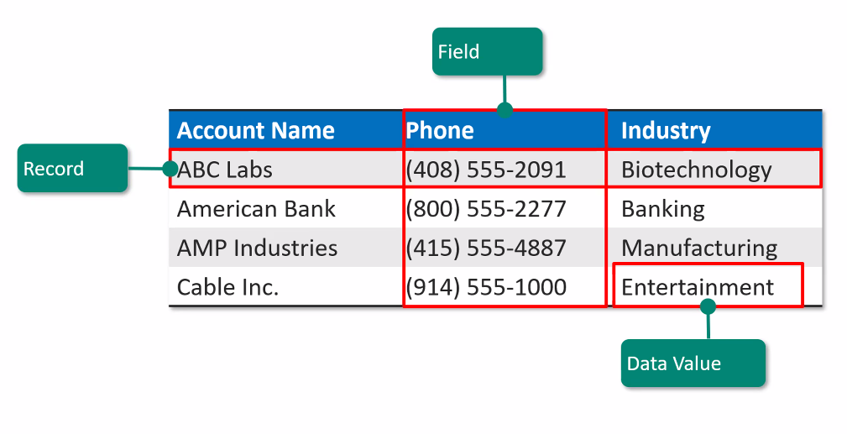
  + Best practice
    - Use what already exists unless absolutely necessary
  + Leads are potential clients that have not been reached out to nor know if they meet any criteria
  + Custom object is created to demo our own data based on business requirements
    - Custom objects can be deleted but can cause issues, much like SQL
  + To create a custom object
    - Navigate to setup > object manager
    - Top right, create object